**Internet dan Aplikasinya**

**TUGAS 3 : Collision pada Hub dan Switch**



**Oleh :**

Nama : Johanes Yogtan Wicaksono Raharja

NIM : 215314105

**PROGRAM STUDI INFORMATIKA**

**FAKULTAS SAINS DAN TEKNOLOGI**

**UNIVERSITAS SANATA DHARMA**

**YOGYAKARTA**

**2022**

1. **Screenshot Topologi**
   1. **HUB**

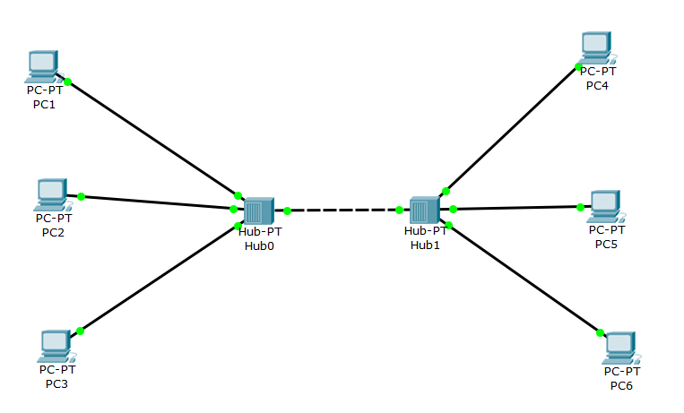

* 1. **SWITCH**

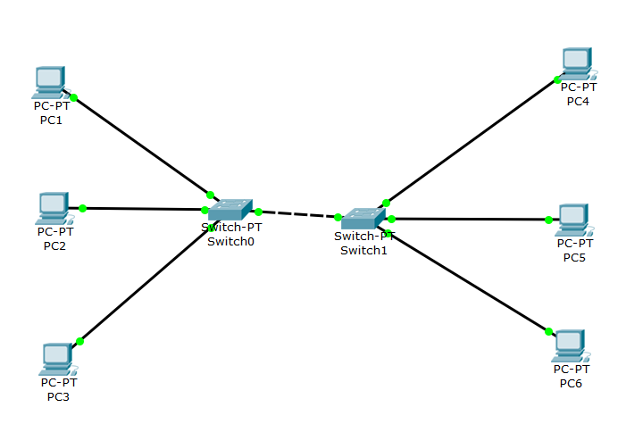

1. **Screenshot IP setiap PC**

**PC1 :**

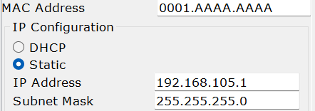

**PC2 :**

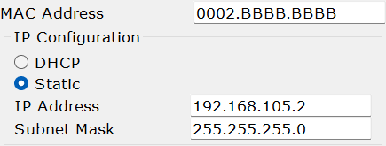

**PC3 :**

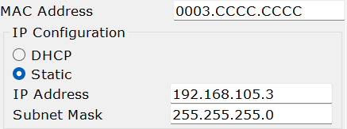

**PC4 :**

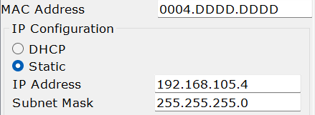

**PC5 :**

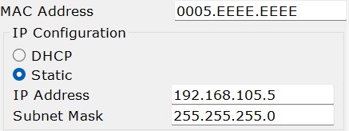

**PC13 :**

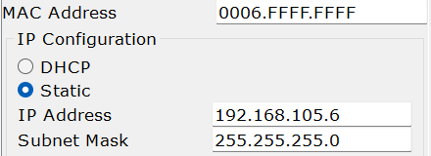

1. **Tabel IP**

|  |  |  |  |
| --- | --- | --- | --- |
| **PC** | **MAC** | **IP** | **SubNet Mask** |
| **1** | 0001.AAAA.AAAA | 192.168.<105>.1 | 255.255.255.0 |
| **2** | 0002.BBBB.BBBB | 192.168.<105>.2 | 255.255.255.0 |
| **3** | 0003.CCCC.CCCC | 192.168.<105>.3 | 255.255.255.0 |
| **4** | 0004.DDDD.DDDD | 192.168.<105>.4 | 255.255.255.0 |
| **5** | 0005.EEEE.EEEE | 192.168.<105>.5 | 255.255.255.0 |
| **6** | 0006.FFFF.FFFF | 192.168.<105>.6 | 255.255.255.0 |

1. **Screenshot Langkah-langkah (Sesuai dengan langkah Langkah pengamatan di modul)**
   * + 1. Sebelum masuk mode simulasi pastikan semua komputer telah terkoneksi (ping sukses)

PC1 > PC2

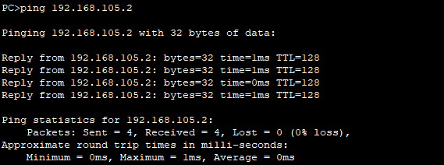

PC1 > PC3

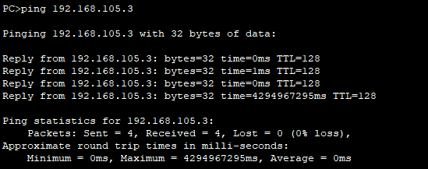

PC1 > PC4

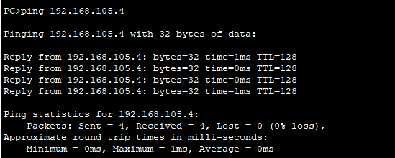

PC1 > PC5

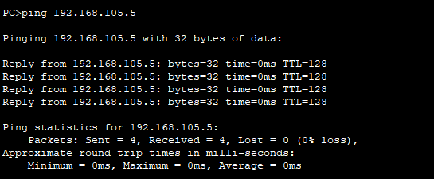

PC1 > PC6

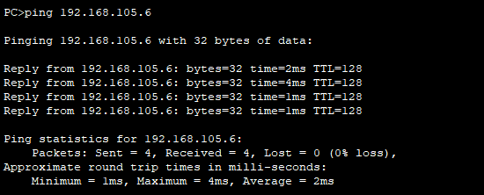

* + - 1. Masuk ke mode **Simulasi** dan **Edit Filter** untuk **ICMP** dengan cara

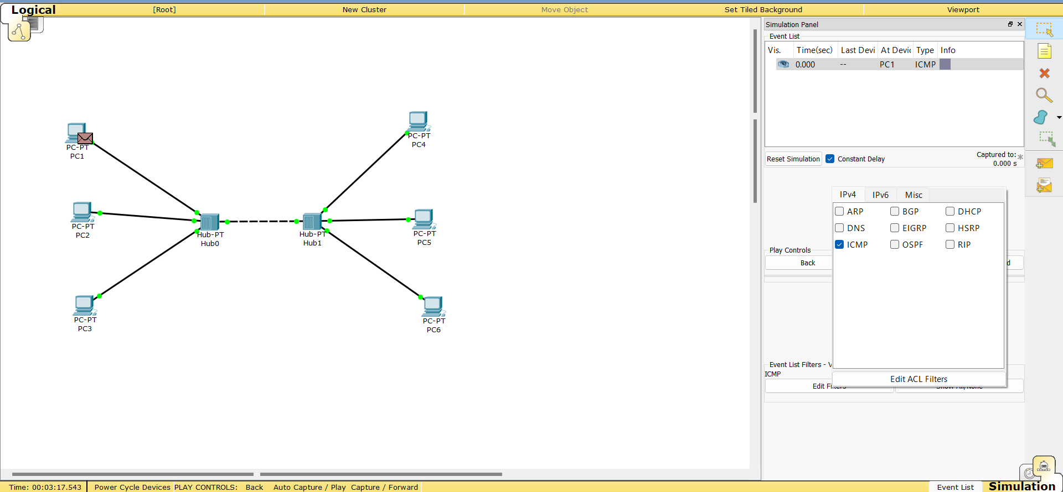

* + - 1. **Kirimkan paket** dari PC 1 ke PC 3 kemudian jalankan animasi:

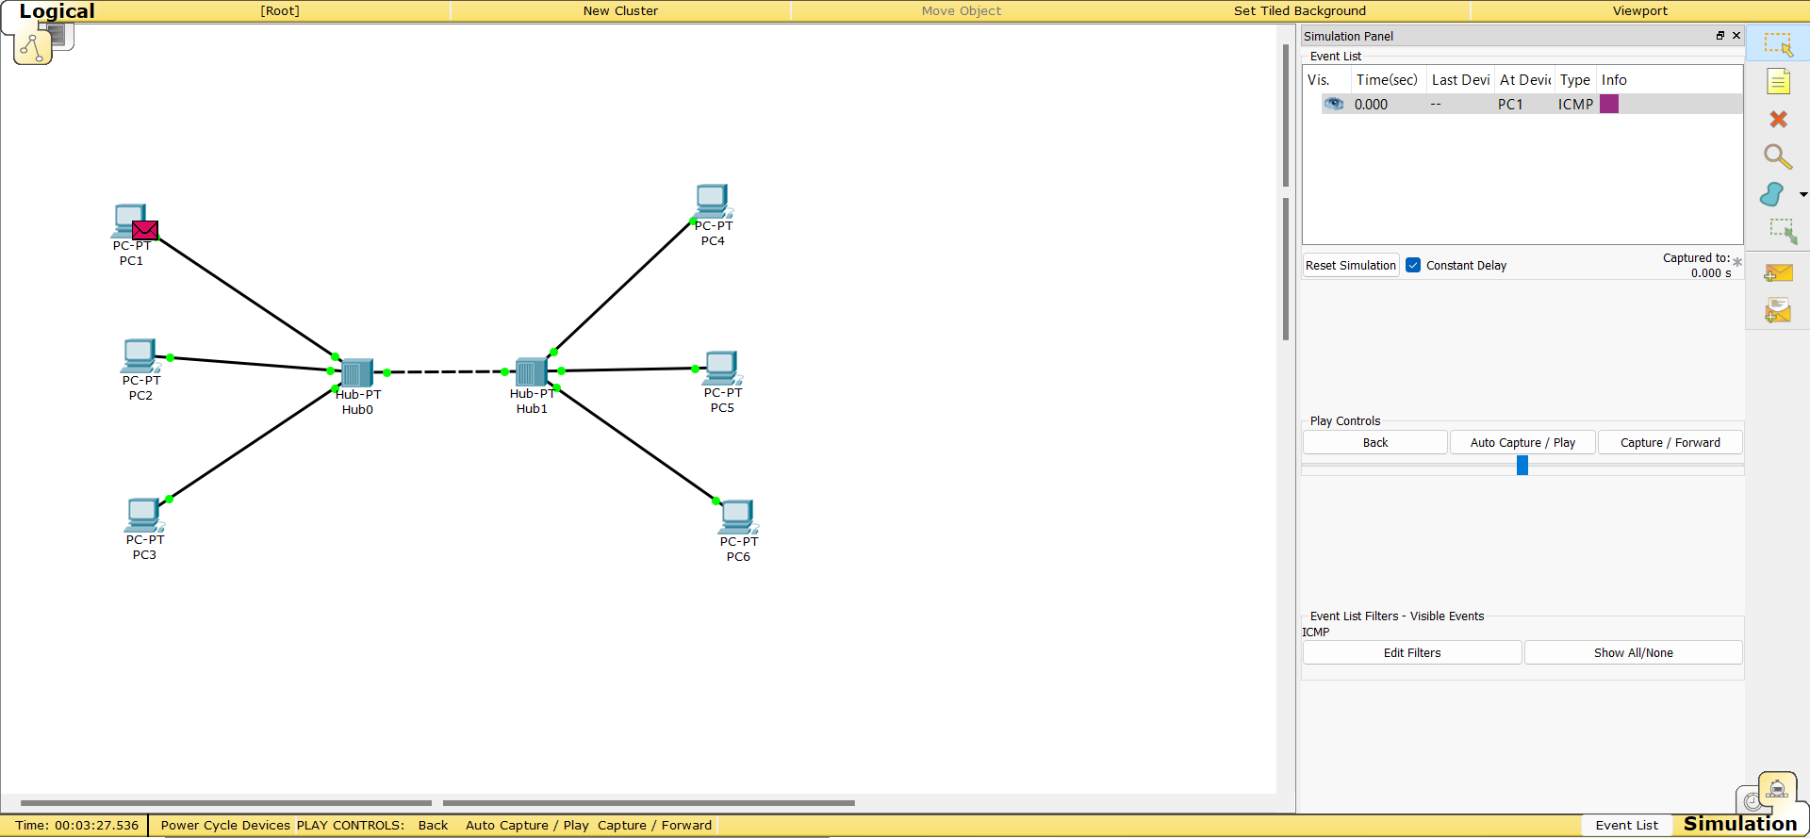

* + - 1. **Amati** Jalannya Simulasi
* **HUB**

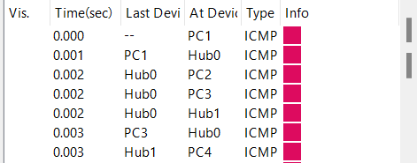



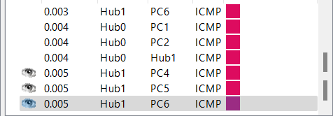

* **SWITCH**

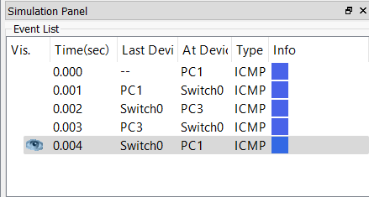

* + - 1. **Inspeksi** Paket  ketika keluar **dari asal – yang dilewati – sampai tujuan** (PC1 – hub – PC3)
* **HUB**

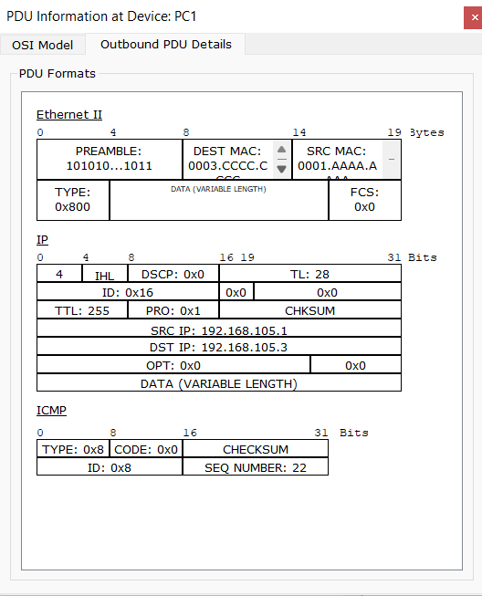

* **SWITCH**

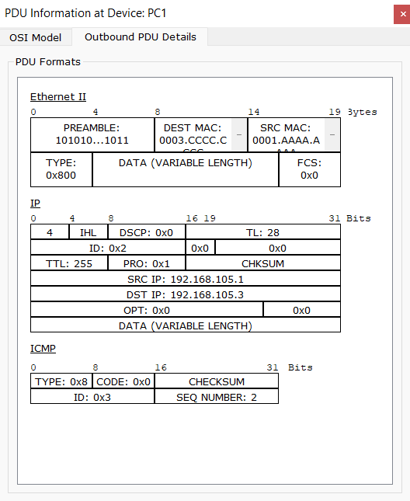

* + - 1. **Inspeksi** Paket  ketika masuk **ke tujuan paket** (PC3)
* **HUB**

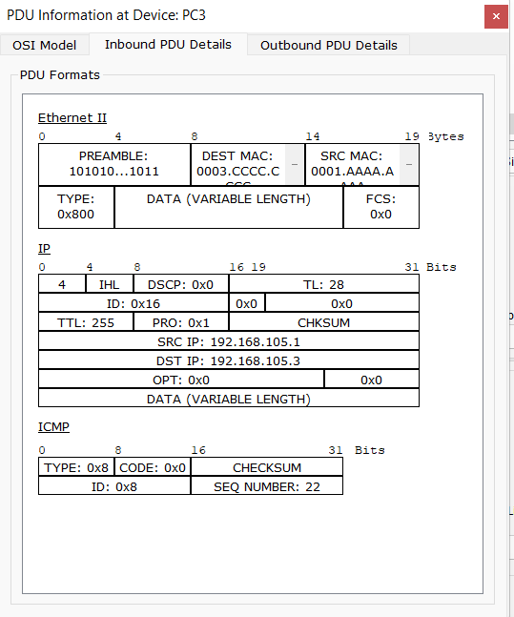

* SWITCH

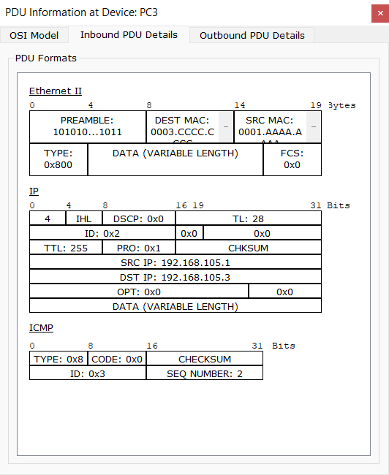

1. **Tabel PDU**

* **HUB**

|  |  |  |  |  |  |  |  |  |
| --- | --- | --- | --- | --- | --- | --- | --- | --- |
| **Paket** | **Last Dev** | **At Dev** | **Inter- face** | **D.Mac** | **S.Mac** | **S.IP** | **D.IP** | |
| **PC1**  **ke**  **PC3** | -- | PC1 | Out | 000.3.CCCC.CCCC | 0001.AAAA.AAAA | 192.168.105.1 | | 192.168.105.3 |
| PC1 | Hub0 | In | 000.3.CCCC.CCCC | 0001.AAAA.AAAA | 192.168.105.1 | | 192.168.105.3 |
| Hub0 | PC3 | In | 000.3.CCCC.CCCC | 0001.AAAA.AAAA | 192.168.105.1 | | 192.168.105.3 |
| **PC3**  **ke**  **PC1** | -- | PC3 | Out | 0001.AAAA.AAAA | 000.3.CCCC.CCCC | 192.168.105.3 | | 192.168.105.1 |
| PC3 | Hub0 | In | 0001.AAAA.AAAA | 000.3.CCCC.CCCC | 192.168.105.3 | | 192.168.105.1 |
| Hub0 | PC1 | In | 0001.AAAA.AAAA | 000.3.CCCC.CCCC | 192.168.105.3 | | 192.168.105.1 |
| **PC2**  **ke**  **PC5** | -- | P2 | Out | 0005.EEEE.EEEE | 0002.BBBB.BBBB | 192.168.105.2 | | 192.168.105.5 |
| PC2 | Hub0 | In | 0005.EEEE.EEEE | 0002.BBBB.BBBB | 192.168.105.2 | | 192.168.105.5 |
| Hub0 | Hub1 | In | 0005.EEEE.EEEE | 0002.BBBB.BBBB | 192.168.105.2 | | 192.168.105.5 |
| Hub 1 | PC 5 | In | 0005.EEEE.EEEE | 0002.BBBB.BBBB | 192.168.105.2 | | 192.168.105.5 |
| **PC5**  **ke**  **PC2** | -- | P5 | Out | 0002.BBBB.BBBB | 0005.EEEE.EEEE | 192.168.105.5 | | 192.168.105.2 |
| PC5 | Hub1 | In | 0002.BBBB.BBBB | 0005.EEEE.EEEE | 192.168.105.5 | | 192.168.105.2 |
| Hub1 | Hub0 | In | 0002.BBBB.BBBB | 0005.EEEE.EEEE | 192.168.105.5 | | 192.168.105.2 |
| Hub 0 | PC 1 | In | 0002.BBBB.BBBB | 0005.EEEE.EEEE | 192.168.105.5 | | 192.168.105.2 |

* 1. **SWITCH**

|  |  |  |  |  |  |  |  |  |
| --- | --- | --- | --- | --- | --- | --- | --- | --- |
| **Paket** | **Last Dev** | **At Dev** | **Inter- face** | **D.Mac** | **S.Mac** | **S.IP** | **D.IP** | |
| **PC1**  **ke**  **PC3** | -- | PC1 | Out | 000.3.CCCC.CCCC | 0001.AAAA.AAAA | 192.168.105.1 | | 192.168.105.3 |
| PC1 | Switch 0 | In | 000.3.CCCC.CCCC | 0001.AAAA.AAAA | 192.168.105.1 | | 192.168.105.3 |
| Switch 0 | PC3 | In | 000.3.CCCC.CCCC | 0001.AAAA.AAAA | 192.168.105.1 | | 192.168.105.3 |
| **PC3**  **ke**  **PC1** | -- | PC3 | Out | 0001.AAAA.AAAA | 000.3.CCCC.CCCC | 192.168.105.3 | | 192.168.105.1 |
| PC3 | Switch 0 | In | 0001.AAAA.AAAA | 000.3.CCCC.CCCC | 192.168.105.3 | | 192.168.105.1 |
| Switch 0 | PC1 | In | 0001.AAAA.AAAA | 000.3.CCCC.CCCC | 192.168.105.3 | | 192.168.105.1 |
| **PC2**  **ke**  **PC5** | -- | P2 | Out | 0005.EEEE.EEEE | 0002.BBBB.BBBB | 192.168.105.2 | | 192.168.105.5 |
| PC2 | Switch 0 | In | 0005.EEEE.EEEE | 0002.BBBB.BBBB | 192.168.105.2 | | 192.168.105.5 |
| Switch 0 | Switch 1 | In | 0005.EEEE.EEEE | 0002.BBBB.BBBB | 192.168.105.2 | | 192.168.105.5 |
| Switch 1 | PC 5 | In | 0005.EEEE.EEEE | 0002.BBBB.BBBB | 192.168.105.2 | | 192.168.105.5 |
| **PC5**  **ke**  **PC2** | -- | P5 | Out | 0002.BBBB.BBBB | 0005.EEEE.EEEE | 192.168.105.5 | | 192.168.105.2 |
| PC5 | Switch 1 | In | 0002.BBBB.BBBB | 0005.EEEE.EEEE | 192.168.105.5 | | 192.168.105.2 |
| Switch 1 | Switch 0 | In | 0002.BBBB.BBBB | 0005.EEEE.EEEE | 192.168.105.5 | | 192.168.105.2 |
| Switch 0 | PC 1 | In | 0002.BBBB.BBBB | 0005.EEEE.EEEE | 192.168.105.5 | | 192.168.105.2 |

1. **Analisa**

Dari pratikum ini, saya dapat mengetahui bahwa perangkat hub dan switch memiliki perbedaan. Seperti pengamatan disimulasi di langkah-langkah laporan, terlihat bahwa dalam perangkat hub untuk mengirikan pesan harus dikirimkan terlebih dahulu ke semua computer dalam topologi agar bisa dicek siapa yang ingin dikirimkan, setelah itu dikirimkan kembali ke hub, supaya dikirimkan kembali ke computer yang mengirim pesan. Berbeda dengan perangkat switch, terlihat bahwa perangkat switch untuk mengirimkan pesan dapat mengatur sendiri computer yang ingin dikirimkan sehingga tidak diperlukan pengecekan di ke semua computer.